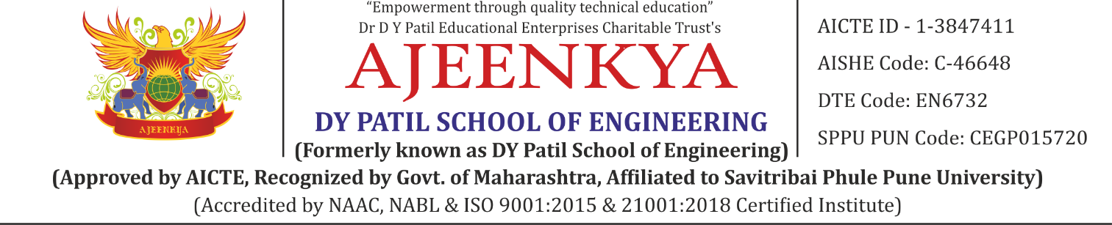

**DEPARTMENT OF COMPUTER ENGINEERING**

**Class: BE A.C.Year : 2023-2024 Sem: II**

**Subject Name: Laboratory Practice V**

**List of Experiment**

|  |  |
| --- | --- |
| **Sr.No** | **Name of Experiment** |
|
| 1a | Design and implement Parallel Breadth First Search based on existing algorithms using OpenMP. Use a Tree or an undirected graph for BFS. |
| 1b | Design and implement Parallel Depth First Search based on existing algorithms using OpenMP. Use a Tree or an undirected graph for DFS |
| 2a | Write a program to implement Parallel Bubble Sort. Use existing algorithms and measure the performance of sequential and parallel algorithms |
| 2b | Write a program to implement Parallel Merge Sort. Use existing algorithms and measure the performance of sequential and parallel algorithm |
| 3 | Implement Min, Max, Sum and Average operations using Parallel Reduction |
| 4a | Write a CUDA Program for Addition of two large vectors |
| 4b | Write a Program for Matrix Multiplication using CUDA C |
| 6 | Linear regression by using Deep Neural network: Implement Boston housing price. prediction problem by Linear regression using Deep Neural network. Use Boston House price prediction dataset. |
| 7a | Binary classification using Deep Neural Networks Example: Classify movie reviews into positive" reviews and "negative" reviews, just based on the text content of the reviews.Use IMDB dataset |
| 7b | Multiclass classification using Deep Neural Networks: Example: Use the OCR letter recognition dataset https://archive.ics.uci.edu/ml/datasets/letter+recognition |
| 8 | Use MNIST Fashion Dataset and create a classifier to classify fashion clothing into categories |